UNIVERSITY OF NAIROBI

SCHOOL OF COMPUTING AND INFORMATICS

CSC 313 FOUNDATIONS OF HUMAN COMPUTER INTERACTIONS

STUDENTS INDIVIDUAL ASSIGNMENTS

BY

PHANUEL ODHIAMBO AYUKA

P15/1704/2014

HIGHER EDUCATION LOANS BOARD WEBSITE.

The product choice I will use in this assignment is the Higher Education Loans Board website <www.helb.co.ke>. This is a governmental organization tasked with financing higher education by offering loans and bursaries to needy students in the country.

**TASK ONE: PACT ANALYSIS**

|  |  |
| --- | --- |
|  | PACT Summary |
| **People**  Who do you think are the key users of this product? Think about the broad user groups that can be identified. List these groups (and their characteristics) in order of priority for the product in question. | Some of the users of the HELP website include:   1. **Students.**   Includes postgraduate, undergraduate, technical college students, high school graduates and PhD students.  Characteristics   * Most of them fall in the age group of 16-25 years. * Some of the users are visually and physically impaired. * Some of them are novice while some are experienced in using technology. * Have different memory and personality characteristics.  1. **HELB staff**.   E.g. data entry clerks, front-office clerks, customer service clerks, disbursement officers and loan collection and clearance officers.  Characteristics   * Most of them fall in the age group of 25-55 years. * Some of the users are visually and physically impaired. * Some of them are novice while some are experienced in using technology. * Most of the users have domain experience. * Have different memory and personality characteristics.  1. **Partners**   Includes Kenya Revenue Authority, University of Nairobi, Afya Elimu Fund Project, and Directorate of Public Service Management, Nation Media Group, Kenyatta University, Visa Oshwal Scholarships, Latimer Education Fund, Banks, and Ministry of State for Immigration and Registration of Persons, National Social Security Fund and Education Bank Loan.  Characteristics   * Most of the partners are organizations. * Most of the organizations have technological and domain experience. * Some are governmental organizations while are non-governmental organizations. * Most of the partners are educational and financial organizations.  1. **General Public**   Includes job seekers checking for vacancy positions in the organization and business organization searching for current tenders.  Media houses such as Citizen, Nation TV and Daily Nation Newspaper also use the site.  Characteristics  Includes both novice and expert technology users.  Some are visually impaired.  Some have the domain experience will some do not. |
| **Activities**  What are the main goals/tasks users will want to achieve with this product? Try to prioritize these. | **Students**   * Apply for loans and bursaries. * View loan disbursement status. * View loan statement reports. * Get loan repayment procedures and offers. * Conduct inquiries and self-billing. * Apply for clearance on full payment of the loans. * Update account details.   **HELP Staff**   * Disburse loans to students. * Approve student loan applications. * Conduct data entry of the student details. * Clear students who have cleared their loan arrears. * Manage students and other staffs’ accounts depending on their system level access. * View their pay slip. * Apply for health services, leave days and clearance.   **Partners and the General Public**   * Get the current affairs and news about the organization. * Get general information about the organization such as mission, core values and vision. * View the current job vacancies available in the organization. * View open tenders in the organization. * View upcoming events in the organization. * Employers also use the site to verify their employee clearance. * The employers also use the site for employee loan remittance.   **Task Characteristics**   * Most of these tasks are well defined such as students’ clearance and loan application process and they are very distinct. * Most of the tasks are carried out by individuals such as viewing loan statements while some are carried out as a group such as data entry of the students’ details. * Most of the activities are staged such as approving loans while others are single such as data entry. * Most of the activities are frequently carried out such as in a year there are a minimum of 10 loan applications via the website. * The site is robust and can accept and process thousands of activities per minute. |
| **Contexts**  Where will this product be used?  Describe the likely environment (Physical and Social). | The site is used mostly in the following physical environments: at school, at the office, at home and even at the move.  The website has no social environment restriction on usage. The users comfortably can use the site from any place of their choice.  The website only needs the devices to have an internet connection for the users to have access.  The website is easy to learn and use. |
| **Technologies**  What type of technology will the users have? Consider input and output. | Input and output devices include phones, tablets, desktops, laptops and iPads.  All these devices need internet connection to access the website.  Most of the data entry in the website is done using desktops and laptops.  The site has both media such as photos and text data types.  The site is easy to navigate using the above devices. |

**TASK TWO: USER RESEARCH QUESTIONNARE**

DEVELOPMENT DESCRIPTION.

The following steps were used to come up with the final HELP website questionnaire:

*Step 1:*

I identified a list of questions that could help me get information about the users of the website. The questions identified were to help me understand the following:

* The user characteristics such as their demographics, product knowledge and frequency of using the HELB website.
* The activities that the users perform in the website and the frequency of such doing such activities.
* Where the users use the website from and which whom.
* The technologies they use such as the devices the users use to access the HELB website.

The output of this step was 50 questions. The questions included open ended questions, rating scales and tick boxes.

*Step 2:*

Refined the draft questionnaire to reduce the number of questions to 15. I corrected redundant questions and questions which were more likely not addressing the PACT analysis components.

*Step 3:*

I revisited the questions and did some corrections. I reviewed ambiguous questions, double-barrel questions and questions that might sound to be leading to the users.

*Step 4:*

The resultant questionnaire was piloted. I gave out 5 questionnaires randomly and they were filled. The respondents recommended some changes.

*Step 5:*

The recommended changes were made and this step resulted to the final questionnaire. The resulted questionnaire is shown in the next page.

HELB WEBITE QUESTIONNAIRE

*Please fill in the questionnaire as correctly as possible. Your responses will highly be appreciated*

1. What is your gender? (*Tick where appropriate*)

Male Female

1. What age group do you fit in? (*Tick where appropriate*)

10-15 16-20 21-25

26-30 31-35 36-45

Above 45, please specify ________________________

1. What is your marital status? (*Tick where appropriate*)

Single Married Divorced

1. How would you rate your computer literacy skills? (*Tick where appropriate*)

|  |  |  |  |
| --- | --- | --- | --- |
| Very Good | Good | Average | Below Average |
|  |  |  |  |

1. Which group of users of the website do you belong? (*Tick where appropriate*)

Student Staff Partner

General Public

1. When did you use the HELB website for the first time?

___________________________________________________________________

1. How frequently do use the HELP website? (*Tick where appropriate*)

|  |  |  |  |  |
| --- | --- | --- | --- | --- |
| Very often | Often | Average | Rarely | Very Rarely |
|  |  |  |  |  |

1. Do you normally use the links provided in the HELB website to access some other websites such as KRA and university websites? (*Tick where appropriate*).

Yes No

1. At what time of the day do you mostly use HELP website? (*Tick where appropriate*).

Morning Afternoon Evening Night

1. Where do you normally access the HELP website from? (*Tick as many as appropriate*).

Home Work School Cybercafé

While in traffic others, please specify_______________

1. Which devices do you use to access the HELP website? (*Tick as many as appropriate*).

Mobile Phone Tablets Laptop

Desktop IPad

Others, please specify ________________________.

1. What do use the website mostly for?

___________________________________________________________________.

1. With whom do you use the website with? (*Tick as many as appropriate*).

Friends Parents Classmates.

1. How would you rate your knowledge of the HELP website? (*Tick where appropriate*).

|  |  |  |  |  |
| --- | --- | --- | --- | --- |
| Excellent | Good | Average | Below Average | Poor |
|  |  |  |  |  |

*Thanks for your response.*

**TASK THREE: PRODUCT ANALYSIS**

**Introduction**

This report is a heuristic evaluation of the Higher Education Loans Boards website: <www.helb.co.ke>. The evaluation recognizes how the website contravenes the tenets of good design principles. The analysis is based on Jacob Nielsen’s ten usability heuristics.

**Analysis Procedure**

Went through the website interface several times to familiarize with the system scope and flow of interaction.

Inspected the product to look for potential problems using the Nielsen’s heuristics as reference.

Prepared the set of problem reports describing the problems that may cause difficulties in the website.

The final documentation of the problem sets was made.

**Inspection Results**

1. **Heuristic 1: Visibility of the System Status**

*The system should always keep the users informed about what is going on, through appropriate feedback within reasonable time.*

The HELB website adheres to the first heuristic for example when a user tiers to login in the “student portal” using a wrong email address, the system generates an error showing that the email address entered is wrong.

This helps the users know the system status, that is, the user cannot login to the system because he/she has entered a wrong an invalid email address or a wrong password. The user is not left wondering as to why they cannot access their accounts.

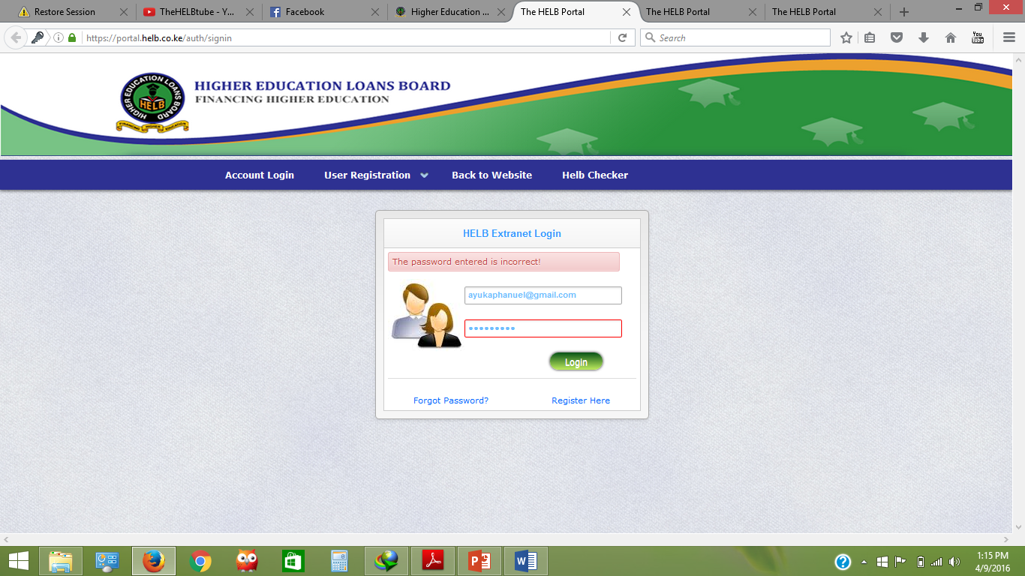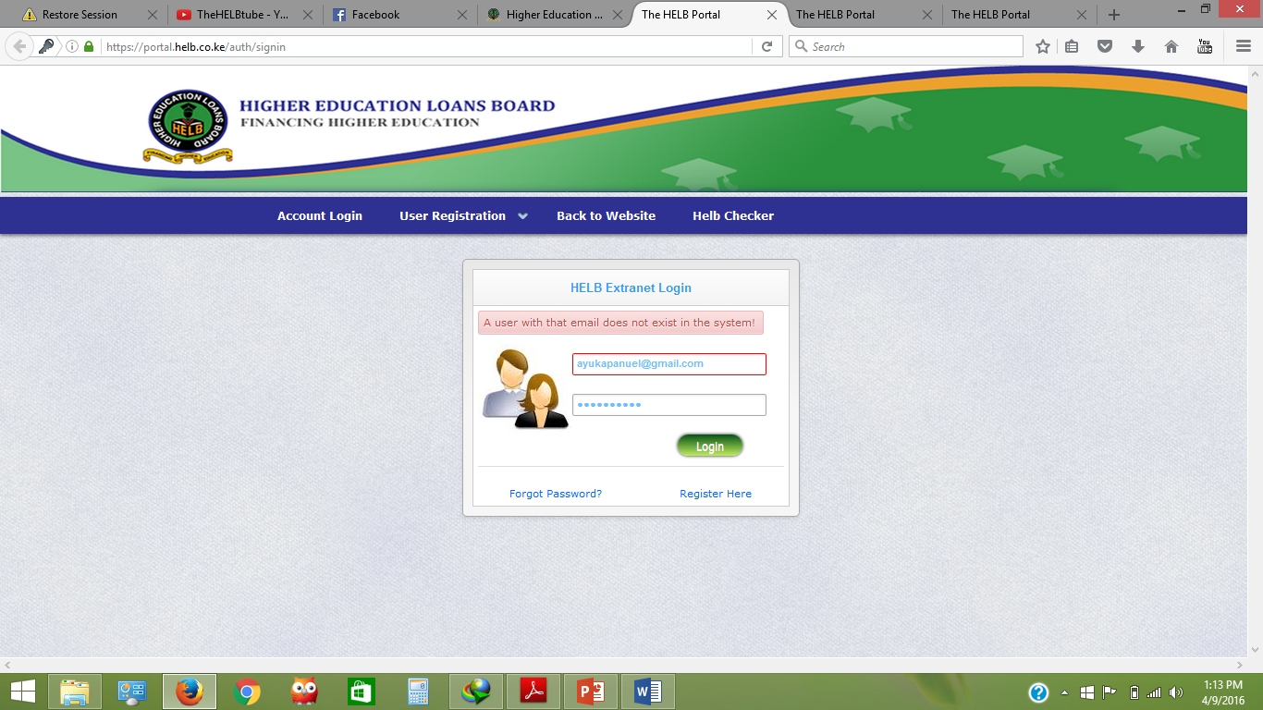

When the user enters a wrong password and a right email address, an error message is generated showing that the password is wrong. The screenshots above below this feature of the site.

1. **Heuristic 2: Match between system and real world**

*The system should speak the users’ language with words, phrases and concepts familiar to the user.*

This website in some pages uses a language that non-native English speakers may have difficulty in understanding. For example on logging into a student’s portal and clicking the “Online Services” drop-down menu, there is a menu for self-billing. The heading “self-billing” might not be well understood by non-native English speakers. The user might need to have the domain knowledge of HELB to understand what the menu does. The heading can even be misinterpreted by native English speakers since its complex. This can be replaced by a simpler term such as “Repayment Self Estimation”.

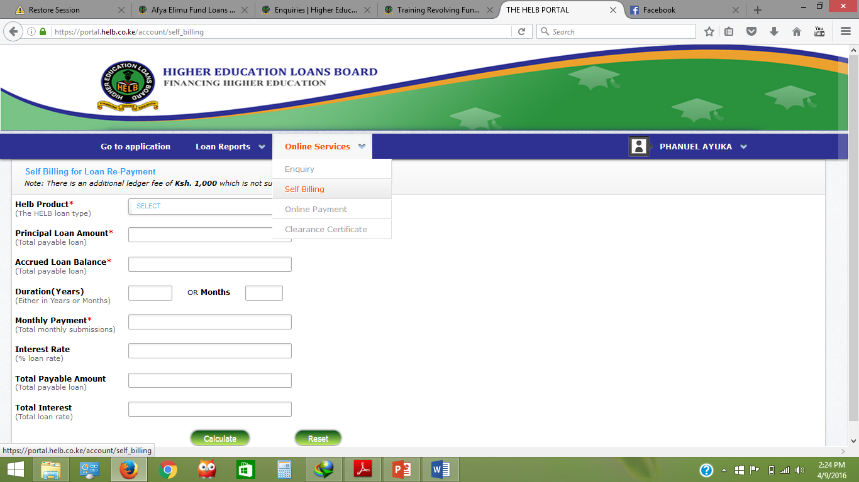

Under “User Registration” then to “Applicants Registration”, the site uses the terms such as “First Name”, “Second Name” and “Last Name” in the form. These names might confuse the users who might not know which name comes first, second or last. The last names can be substituted using sir name so that the first and the second names can mean the Christian names of the user. This would be simpler than having the user choosing which name comes first or last.

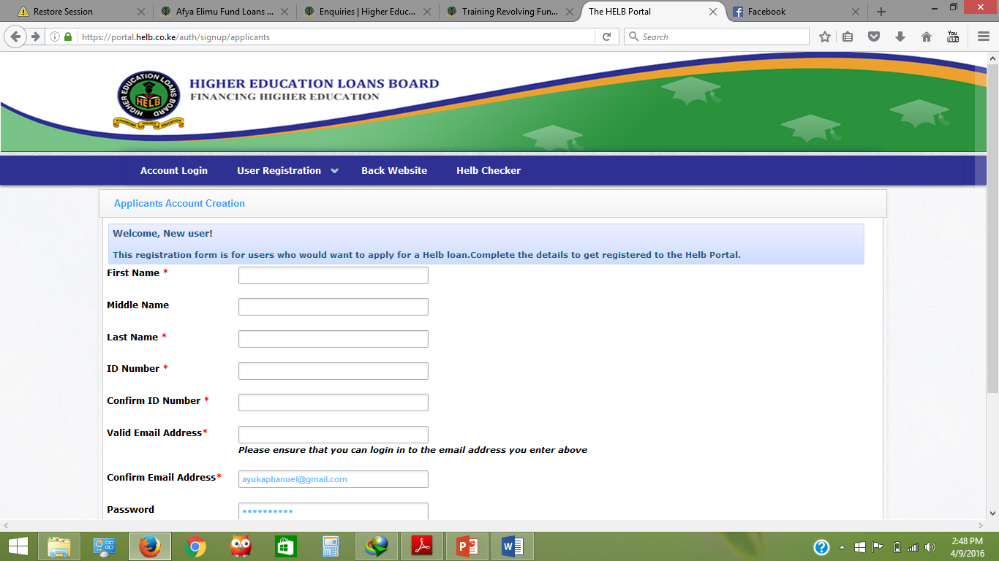

But on a general view, the website uses a language which is a strong match with the real world. The words and phrases are easy to understand.

1. **Heuristic 3: User control and freedom**

*Users often choose system functions by mistake and will need a clearly marked “emergency exit” to leave the unwanted state without having to go through an extended dialogue. Support undo and redo.*

The HELB website does not comply with the heuristic of user control and freedom. The site has no “go back”, “undo” or “redo” buttons in all its pages. This means that the user will have difficulty in going back to the previous state if in any case they choose any system function by mistake. The site does not have “emergency exit” in all its pages.

The user can never know where they are in the site, how deep they have gone into the site, how far they are from the home page and how to navigate backwards to the home page. This only leaves the users with two options: to exit the website or to use the go back button provided by the web browser with is of course not a good user interaction design.

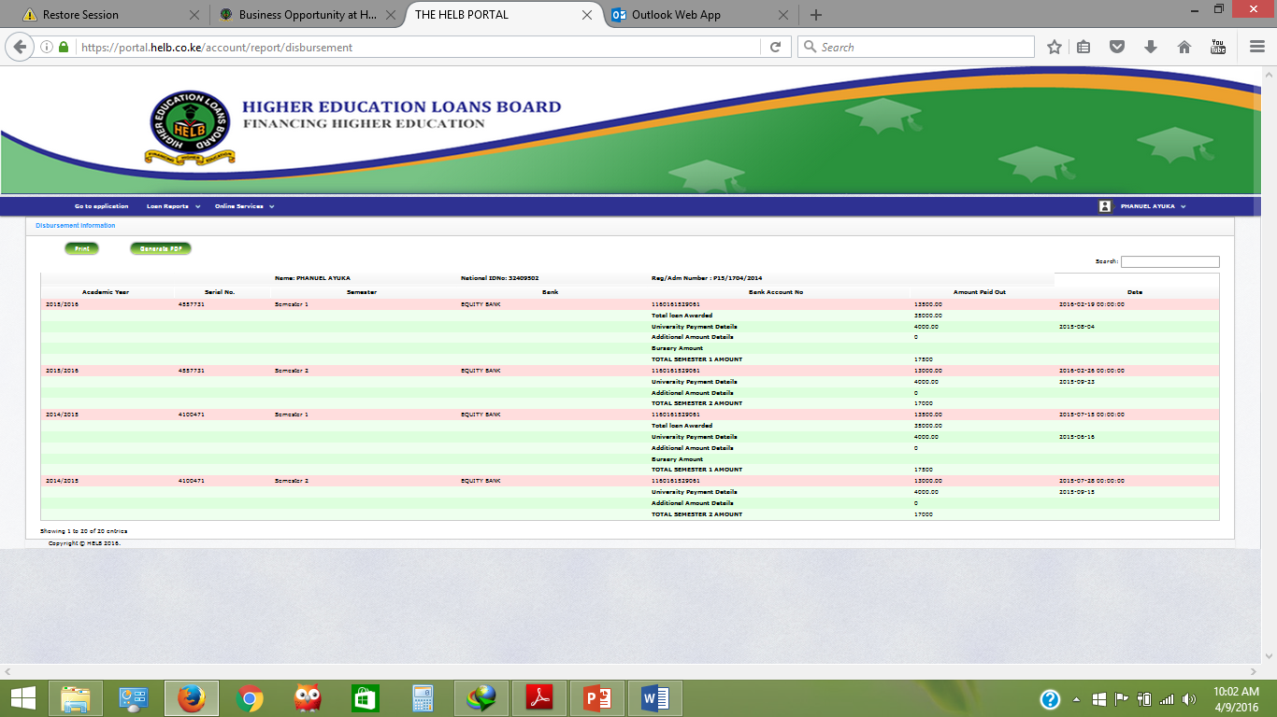

1. **Heuristic 4: Consistency and Standards**

*Users should not have to wonder whether different words, situations or actions man the same thing. Follow platform conventions.*

The site general layout maintains a good consistent standards and convention. The pages such as “Home”, Contact us”, “Careers”, “Procurement”, “HELB Products” and “Loan Repayment”. The location of each function did not change as one go through these pages. This allows the users to recognize and identify that they are still within the website thus a good user interaction design. This is shown by the screenshots below from the “Home” and “Procurement” pages of the website.

 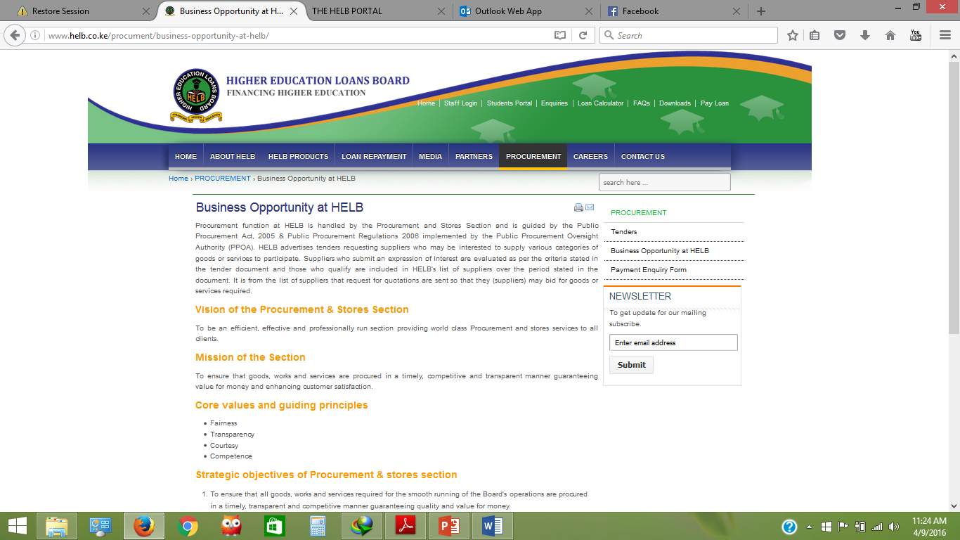

However, this is not the case ehen you click on the “Staff Login” link. The login page for the staff is totally different from the layout of the HELB website. There is no consistecy in color and layout. This inconsistency might cause a problem to the users who might think that they have gone to a didfferent website other than the HELB website. The “Staff Login” page should be made to have a consistent layout and color scheme which is the same as all other web pages. The screenshot below shows the “staff login” page.

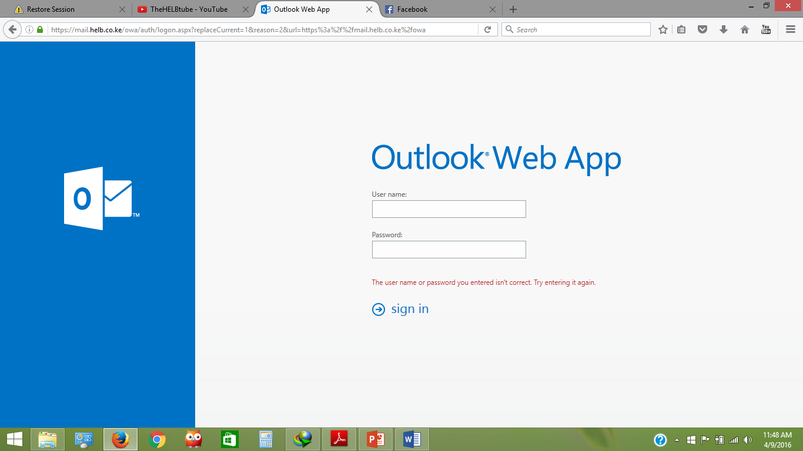

1. **Heuristic 5: Error Prevention**

*Even better than good error messages is a careful design which prevents a problem from occurring in the first place. Either eliminate error-prone conditions or check for them and prevent the users with a confirmation option before they commit to the action.*

The HELB website has good error prevention mechanisms. For example in the “Students signup”, when one tries to sign up using an already registered national identification number, the system populates an error message indicating that the ID has already been registered to prevent more than one student using a single ID number. It prevents a user having multiple user accounts that would cause misappropriation of funds.

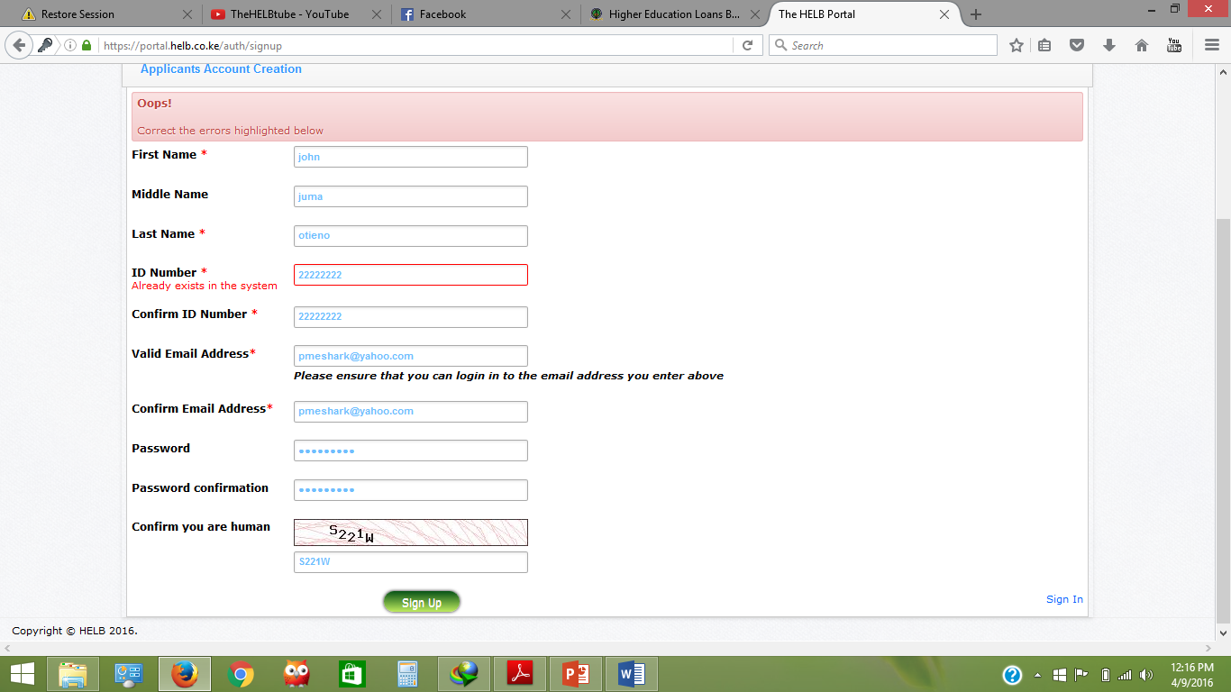

The registration form as well does not allow the users to submit empty forms with no entries. The will show errors showing the user to fill all the entries as shown below.

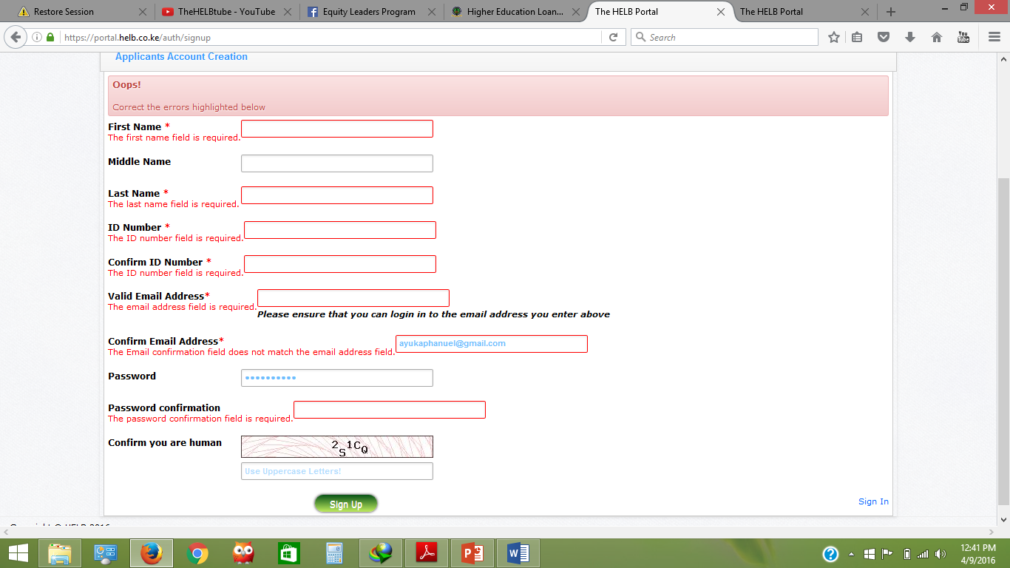 This a good error prevention mechanism thus a good user interface design.

1. **Heuristic 6: Recognition rather than recall**

*Minimize the user’s memory load by making objects, actions and options visible. The user should not have to remember information from part to part of the dialogue to another.*

The HELB website adheres to this heuristic. For example when a user is logged into a student’s account and wants to apply for loan, all the loan applications which are currently open are listed as shown.

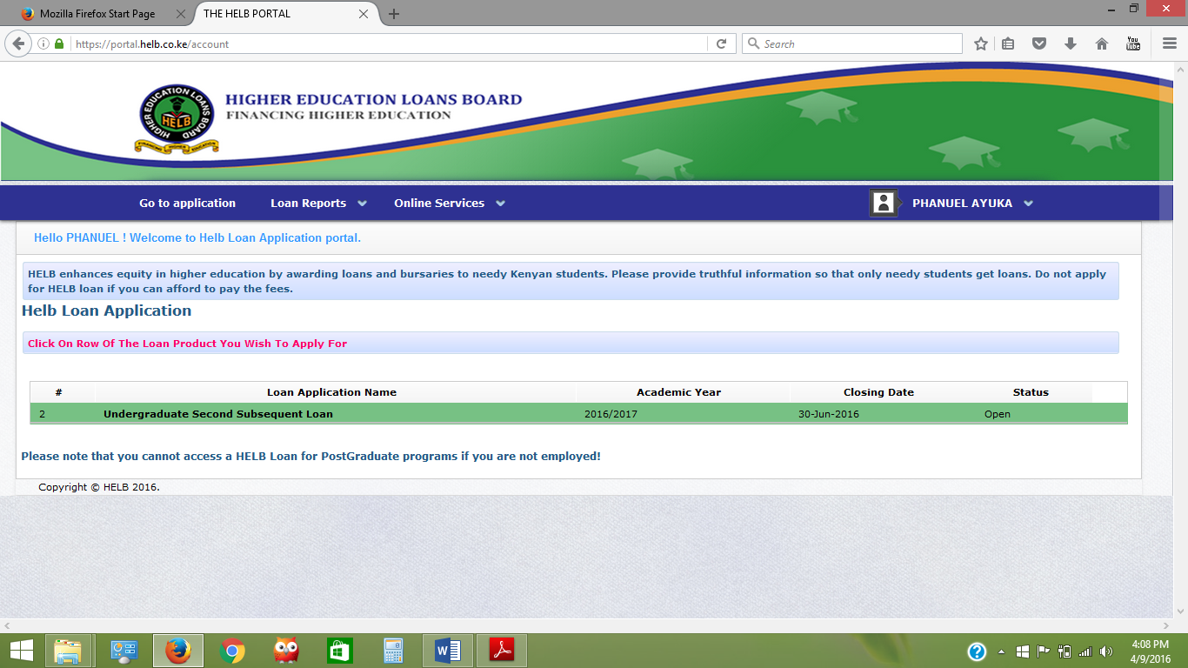

This list of all the loans available for application helps the users such that they do not have to check all loans that HELP offers then think whether they are available for application or not for them to apply. This feature thus allows the users to recognize the loan than to recall.

However the website does require the users to recall the interest rate which is being used by the organization when they are trying to calculate the amount of money they might pay after being awarded the loans. This is evident when a user uses the “self-billing” option under the “Online Services” menu. The system should populate the interest rate internally rather than the users entering by themselves.

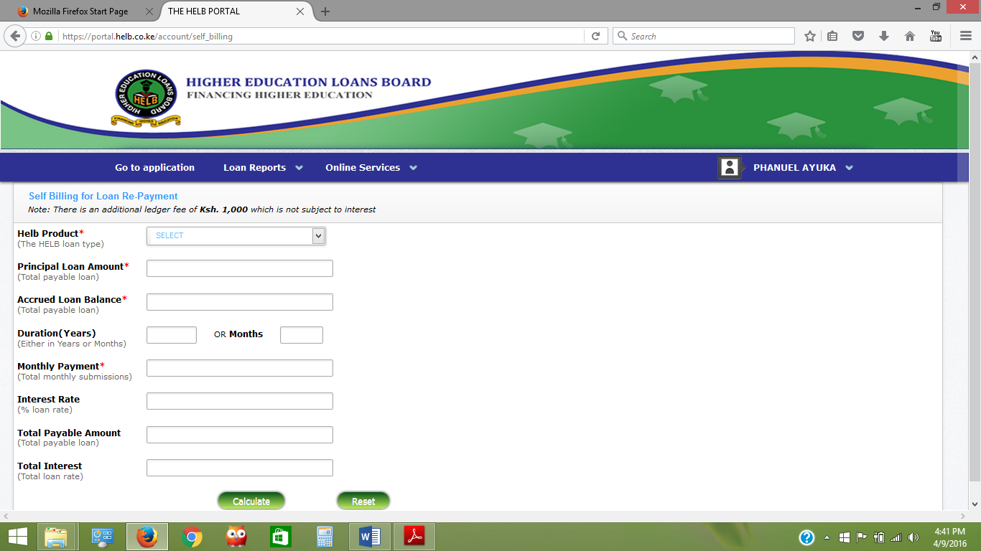

1. **Heuristic 7: Efficiency and flexibility**

*Accelerators may often speed up the interaction for the expert user such that the system can cater for both experienced and inexperienced users. Allow users to tailor frequent actions.*

The HELB website has a page for frequently asked questions (FAQs), which can assist a user get assistance by referring to the previous asked questions. This is faster than contacting the HELB offices for help and support.

The website also has a search box which is very resourceful for novice users. They can use the search box to search for the type of loan, services, tenders and careers within the organization.

The site is generally efficient and flexible.



1. **Heuristic 8: Aesthetic and minimalist design**

*Every extra unit of information in a dialogue competes with the relevant units of information and diminishes their relative visibility.*

The website has used motion pictures and words in the home page with might distract the user. The information provided by the motion pictures and words actually are not very important to the user thus contravenes the minimalist design. The motion pictures and words are shown below. They are causing a big disruption to the users who want real data or services of the website.



The HELB website is also a good example of aesthetic and minimalist design. The website has white spaces on almost all its pages where there is no information added. This prevents information overload to the users. The white spaces guides the user’s eyes down and across the page more quickly and easily with minimal confusion for the user.

The pages in the website has little text and images thus minimalist design.

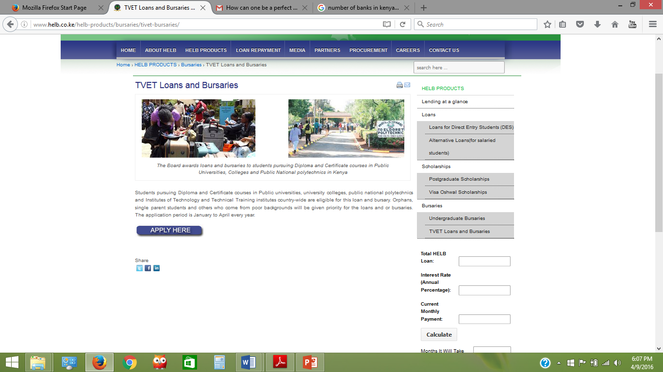

1. **Help users recognize, diagnose and recover from errors.**

*Error messages should be expressed in plain language, precisely indicate the problem and constructively suggest a solution.*

The system populates errors in plain texts that precisely indicate the problem. This is a satisfaction of the ninth heuristic. For example in the in the students login portal, when the user enters a wrong password or email address, the system shows an error message on the screen. This error messages helps the user identify the mistakes they have made and also allows them to correct the errors without leaving the site. The users doesn’t get frustrated trying to understand the error since they are in simple plain and easily understood text.





The system however does not provide a constructive suggestion of the solution thus an improvement should be made on the site to provide or suggest recovery solutions such as “Please enter the correct password/email address to continue”.

1. **Help and Documentation**

The HELB website has a “Contact Us” menu in all the major pages of the site. The “contact us” page helps the user know the physical location of HELB offices since it has a google map location of the offices. The page also has the Post Address of HELB and several email address. This provides help to the users.

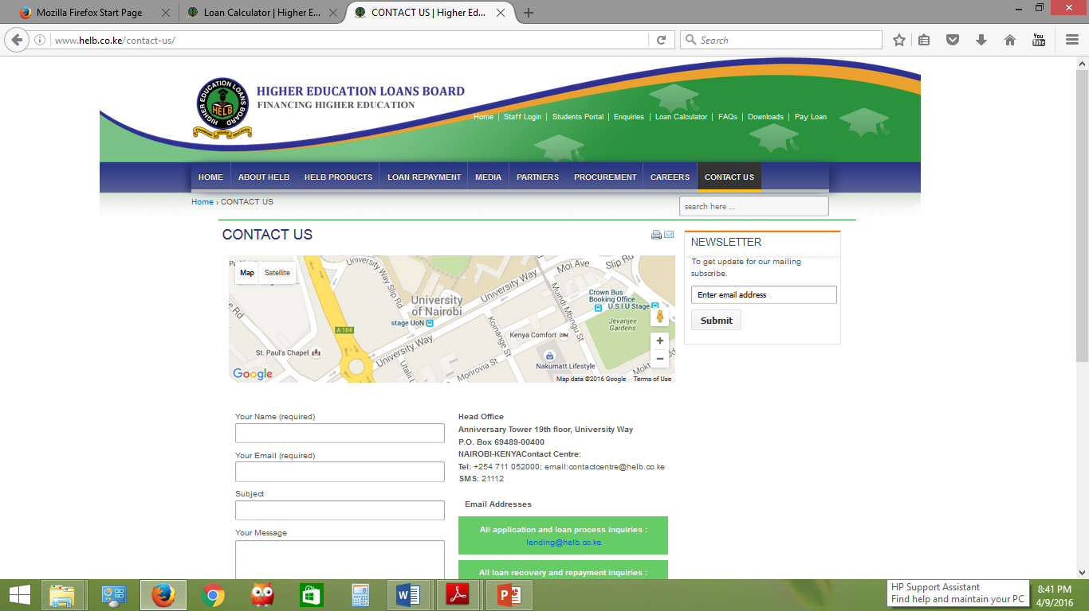

The “contact us” menu however is not included into the students’ portal. This causes some worries because the student users have to go back to the main web pages to get the “contact us” functionality.

**TASK FOUR: USABILITY/ USER EXPERIENCE TEST**

**HELB WEBSITE USABILITY PROCEDURE**

**HELB WEBSITE USABILITY TEST INTRODUCTION SCRIPT**

Test conducted by

PHANUEL ODHIAMBO AYUKA

Test Date: 20/04/2016

Hi, {name of the participant}, thank you for coming. My name is Phanuel Odhiambo Ayuka and I am a student at the University of Nairobi. I am going to walk you through the todays’ session.

Before we start I have some piece of information for you.

We are testing the Higher Education Loans Board website to learn as much as we can about how people us it. The purpose of this research is to help us to identify flaws and problems as much as possible that the site might be having.

The session will take approximately 40 minutes; we does not want to take much of your time since we value it.

Please remember, during the 40 minutes, we are testing the HELB website and not you. If any case there will be mistakes during the session, do not worry. It is the products fault and not yours. Actually finding the fault is very important in this exercise and helps us improve the website so as to make it suite the intended purpose with full user satisfaction.

During the whole activity, kindly try to think out aloud. Share anything that is in your mind. Tell me what you are looking for in the screen, what you like, what you do not like, what your thoughts are about the activity you are undertaking and any other thing. Your opinion and thoughts are very important in this session and without them, we might yield nothing from the whole activity. For this reason, we want learn about your honest reactions to the HELB website.

Do you have any questions so far? Feel free to ask any question.

If you have any doubts during the test, feel free to ask me any question. Our main intention is to learn about your experience with the HELB website, so I might not be able to guide you through. Remember I might not be able to answer your questions during the session but I will be glad to answer all your questions after we are done with the session.

With your consent, we are going to record this session. We will record the actions on the screen (this will give use full picture of the session for future analysis), your voice and your face. The recording might be shared with others teams concerned with the development of the HELB website.

If you won’t mind, I would ask you to sign at the space provided at the end of this page. It gives us the permission to record the session and we are going to keep the data confidential as possible and available to the relevant authorities within the organization.

Am also going to take short notes to help me analyze the session. I hope you won’t mind.

I understand that my usability test session will be recorded. I grant you the **permission** to use the recording for **internal use only**, for the purpose of improving the designs tested.

Signature: ______________________________________

Name: _________________________________________

Before we proceed to the website, I would like to ask you some few questions.

*[The questions are about the demography and general use of the website]*

1. How did you learn about the HELB website?
2. Have you ever used any other website like the HELB website?
3. What is your affiliation with HEB? (student, staff, media, general public)
4. Roughly how many hours do you spend using the internet?
5. Which device do you frequently use to access the HELB website?

Thank you, the context you provided was very helpful.

*[Open the HELB website in the web browser]*

If you feel ready, we can begin the test.

*[Sit slightly below and to the right of participant so she won’t be able to see your face during the test and read your emotions. Turn on the recording software.]*

We have 10 tasks that that I would like you to go through today. I am going to read to you the first task and if you have any questions about it, you can ask immediately without fear.

*[Read the first task. Male sure that the participant understands it. Hand her/him the printed version in case she needs to a reminder of the details of the tasks later on].*

Start whenever you feel ready and once again-please share your thoughts with me aloud.

*[The user should try all the tasks]*

Thank you very much for this session, your feedback is very important to us.